2022 AUCTION LIST 2
XX-01 NAMIBIA - 10 DAY HUNTING SAFARI INCLUDING ETOSHA NATIONAL PARK TOUR:
Justus Brits is offering this 10-day trip for two hunters and two non-hunters. There will be 8 days of guided 1x1 hunting plus 2 days of travel. Trophy fees are included for one oryx and one kudu for each hunter. The hunt must be taken between February 1 and November 30 in 2022 or 2023. You may use rifle or bow for the hunt and firearms rental is available at $25/day. Hunt can be upgraded to include additional days and additional animals per the price list. Extra hunters can be added for $300/day and extra non-hunters are welcome at $123/day. Included are the services of a professional hunter, accommodations, meals, drinks, daily laundry, trophy recovery and field prep, and transport of trophies to shipper. Enjoy evenings and nights in an African-style thatched-roof stone bungalow with swimming pool and free internet. Windhoek airport pickup and return are extra cost at $400 one way for up to 3 persons. Overnight accommodations in Windhoek will be required if arrival is past 3:00 p.m. The tour of magnificent Etosha National Park offers the opportunity to see lions, giraffes, elephants and other classic African animals as well as the endangered black rhino. Contact Justice Brits directly for more details and to book your adventure.
DONATED BY: Afrihunt Safaris Namibia, Justice Brits
Farm Ohange, Otavi, Namibia
Phone: 011-264-81-148-6807 Fax: 011-264-88-615-575
Email: Justus@afrihuntssafaris.com Web: afrihuntsafaris.com
Value: $10,890
XX-02 ALASKA - 4 NIGHTS & 3 FULL DAYS FISHING ADVENTURE FOR 2 ANGLERS:
Welcome to beautiful wild Alaska! Come experience the bountiful waters of Resurrection Bay and the Gulf of Alaska as you fish out of the historic town of Seward on the south shore of the Kenai Peninsula. This is a 4-nights, 3-days adventure for 2 people to be taken any time May-October in 2022 or 2023. It includes 4 nights of lodging in our own private lodge in Seward, 3 full days of ocean fishing with all fishing gear provided with Gone Again Charters, lunch and beverages (including cold beer) on the boat, a fully stocked kitchen at the lodge and filleting of your daily catch. Daily catches vary depending on the time of the year, but typical fish include halibut, multiple species of rockfish, Chinook (king) salmon, Coho salmon, ling cod, and Alaskan/Pacific cod. Other scenic highlights to enjoy while fishing are whales, abundant seabirds and amazing mountain views with glaciers, grazing mountain goats and other wildlife. Not included is transportation to Seward, fish packaging, shipping, taxidermy, license fee ($60 per angler), lodge cleaning fee $120 and gratuities. Up to 4 extra anglers may be added at $1,800 each. Contact Drake Dawson directly for more details and to book your trip.
DONATED BY: SAFARI UNLIMITED, Drake Dawson
2415 Cedar Lake Dr., New Bloomfield, MO 65063
Phone: 573-544-2041 Email: safariunlimitedllc@gmail.com
Web: safariunlimitedworldwide.com
Value: $6,795

XX-03 SPAIN - RED STAG, FALLOW DEER, MOUFLON SHEEP OR ROE DEER HUNT:
Alfonso Fabres of Huntinspain has donated a trophy Red Stag or Fallow Deer or Mouflon Sheep or Roe Deer bow or gun hunt in Spain for one hunter to be taken in the 2022-2023 season. The number of days for this hunt is unlimited. However, the hunt is over if the trophy is collected or wounded or if three reasonable chances are missed. Of course, all other Spanish game in the area will also be available including 2 subspecies of Chamois and 4 subspecies of Ibex per the price list in case the hunter wants to upgrade the hunt. Accommodations for this hunt are unique: an 18th century lodge which has been refurnished with all modern facilities. It is based in one of Spain’s oldest bull fighting ranches, where you will be able to see and take pictures of these free, impressive and beautiful animals in the wild, and if you enjoy a challenge, you are welcome to fight one of them. If you are keen on culture and tradition, you will enjoy visiting Salamanca. This city is one of the best examples of Romanic and Gothic Art in the world. It is full of Roman bridges, cathedrals, castles and monasteries. A tour of Salamanca is highly recommended if you come with a companion on this trip. Salamanca was elected the European capital of Culture in 2002. INCLUDED: hunting permit tag; trophy fee even up to gold medal; full accommodations; transportation; 1x1 professional hunting guide; and red fox, if seen during the hunt. NOT INCLUDED: hotels while in Madrid; hunting license & insurance $290; export permit & veterinary certificate $200 per trophy; extra daily rates while hunting other species; non-hunting companion $250/day; and 21% VAT. Alfonso Fabres has a doctorate degree in Architecture and Urbanism. He has been in the outfitting business for 30+ years. He is Vice-President of Spain’s Hunting and Tourism Association, is a member of the Board of Directors in Castilla-Leon State for hunting resources and is a Director of the Spanish Professional Hunters Association. He has also won the Spanish Award from the Spanish Hunting Federation. He was the guide to the King of Spain when the King two different times took the then all-time world record Spanish Ibex.
DONATED BY: HUNTINSPAIN, Alfonso Fabres
Pedro-Lien/Las Veguillas, 37454 Salamanca, Spain
Phone/Fax: 011-34-92-3380001
Email: info@huntinspain.com Web: huntinspain.com
Value: $9,650

XX-04 $500 GIFT CERTIFICATE FOR TAXIDERMY/CUSTOM WOOD WORK:
Owen Eldred of The Wildlife Gallery has generously donated a $500 gift certificate to be applied to incoming taxidermy or custom wood work good through 03-04-23. The Wildlife gallery is the taxidermy studio used and recommended by famous hunter and TV personality Larry Weishuhn.
DONATED BY: THE WILDLIFE GALLERY INC. CUSTOM TAXIDERMY STUDIO, Owen Eldred
737 Jackson Road, Blanchard, MI 49310
Phone: 989-561-5369 Fax: 989-561-2233
Email: taxidermy@thewildlifegallery.com Web: thewildlifegallery.com
Value: $500

XX-05 OHIO - THREE DAY ESTATE TROPHY WHITETAIL HUNT FOR TWO HUNTERS:
Our friends at Briarwood in Bellefontaine, Ohio have generously donated a $4,400 credit toward a 3-day/4-night estate hunt for two Northeastern Whitetail Deer. Included are daily fees for 2 hunters ($2,400 value) and $1,000 trophy fee credit per hunter toward the harvest of two trophy (up to 170" SCI) whitetails. Daily fees include lakefront lodging, on-site chef for private meals, beverages/liquor, professional guide, transportation of trophies to local meat processor and taxidermist and fishing opportunities on sixteen lakes and four streams. Applying this donation will leave a balance of $4,000/hunter due upon completion of the hunt. Method of take is hunter’s choice. Hunters have option to harvest bigger and/or additional animals per current price list. Briarwood is located 45 minutes northwest of Columbus, Ohio. Hunt to be taken mid-September to mid-December, 2022 or 2023. Taxidermy and shipping of trophies and gratuities are not included, but taxidermy and shipping can be arranged. Airport pickup and return at Columbus or Dayton is available for $200. Contact Drew McCartt directly for more details and to book your hunt.
DONATED BY: BRIARWOOD SPORTING CLUB, Drew McCartt
2001 Twp. Road 55, Bellefontaine, OH 43311
Phone: 937-593-8045 Cell: 614-403-4886
E-mail: drew@briarwoodclub.com Web: briarwoodwhitetails.com
Value: $4,400
XX-06 OHIO - THREE DAY ESTATE TROPHY WHITETAIL HUNT FOR TWO HUNTERS:
Our friends at Briarwood in Bellefontaine, Ohio have generously donated a $4,400 credit toward a 3-day/4-night estate hunt for two Northeastern Whitetail Deer. Included are daily fees for 2 hunters ($2,400 value) and $1,000 trophy fee credit per hunter toward the harvest of two trophy (up to 170" SCI) whitetails. Daily fees include lakefront lodging, on-site chef for private meals, beverages/liquor, professional guide, transportation of trophies to local meat processor and taxidermist and fishing opportunities on sixteen lakes and four streams. Applying this donation will leave a balance of $4,000/hunter due upon completion of the hunt. Method of take is hunter’s choice. Hunters have option to harvest bigger and/or additional animals per current price list. Briarwood is located 45 minutes northwest of Columbus, Ohio. Hunt to be taken mid-September to mid-December, 2022 or 2023. Taxidermy and shipping of trophies and gratuities are not included, but taxidermy and shipping can be arranged. Airport pickup and return at Columbus or Dayton is available for $200. Contact Drew McCartt directly for more details and to book your hunt.
DONATED BY: BRIARWOOD SPORTING CLUB, Drew McCartt
2001 Twp. Road 55, Bellefontaine, OH 43311
Phone: 937-593-8045 Cell: 614-403-4886
E-mail: drew@briarwoodclub.com Web: briarwoodwhitetails.com
Value: $4,400

XX-07 $500 GIFT CERTIFICATE FOR TAXIDERMY WORK:
This donation from Lombardo's Taxidermy consists of a $500 gift certificate to be applied to new incoming taxidermy work. Tanning of flat mounts is not included. John has donated his services to the SCI Detroit Chapter Humanitarian Services Youth Programs for many years.
DONATED BY: LOMBARDO’S TAXIDERMY STUDIO, John Lombardo
10278 Dixie Hwy., Fair Haven, MI 48023
Phone: 586-725-4352 Fax: 586-725-3320
E-mail: jlombardo370@aol.com
Value: $500

XX-08 FLORIDA – 1.5 DAY WILD BOAR HUNT WITH BAY DOGS FOR 4 HUNTERS:
This is a 1.5-day group hunt for four hunters using weapons of choice for wild boar with bay dogs at Ross Hammock Ranch, a Florida Premier Hunting Destination, that contains many species of both native and exotic game. The hunting ranch is located on Florida's Gulf Coast a two-hour drive NW from Orlando. Donation includes: all meals, snacks, drinks, guides, cook and maid service; one nights lodging in the fantastic RHR Cypress Log Lodge; use of 3D archery and gun ranges, ranch vehicles, and a pack of bay dogs that will insure a successful and very exciting hunt; basic skin/quarter/clean and ice down of game taken; and the trophy fee for the first hog taken by the group (one hog per group not per person). The purchasers of this hunt may add additional wild boars, other game, additional hunters and guests, additional hunting days and additional nights lodging at RHR published pricing (hog trophy fees are $295/meat hog and $595/trophy boar). Hunt to be taken within one year from the date of this auction. Contact Terra Ross directly for more details and to book your hunt.
DONATED BY: ROSS HAMMOCK RANCH, Terra Ross
P.O. Box 505, Inglis, FL 34449
Phone: 352-427-5807 or 352-303-7909
Email: rosshammockranch@gmail.com Web: rosshammockranch.com
Value: $2,159

XX-09 SASKATCHEWAN – BLACK BEAR HUNT OVER BAIT FOR ONE HUNTER:
This donation is for a 6-day/7-night guided black bear hunt over active baited stands for one hunter in northern Saskatchewan in the spring or fall of 2022 using weapon of choice from among rifle, muzzleloader, crossbow and bow. Fly into Saskatoon, rent a vehicle and drive about four hours to the bear hunting cabin. Includes accommodations (cabin or campers depending on hunt location), meals, transportation to active baited stands, trophy recovery and trophy prep. Not included are weapon permit, licenses and gratuities. Bears in this area are about 30% color phase. Additional hunters are welcome at $4,000 each, and non-hunters are welcome at $700 each. Trip can be upgraded to include fly-in fishing to the Hepburn Lake lodge if there is room available at that lodge, and if enough hunters want to do the upgrade. The fishing upgrade extends the trip to 10 days. Contact Arlee Thideman directly for more details and to book the hunt.
DONATED BY: HEPBURN LAKE LODGE, Arlee Thideman
P.O. Box 1239, Preceville, SK Canada S0A 3B0
Phone: 306-547-8231 or 306-547-7918
Email: hepburnlakelodge@sasktel.net Web: hepburnlakelodge.com
Value: $4,000

XX-10 SERBIA – FALLOW DEER HUNT WITH RIFLE FOR 2 HUNTERS:
This is a fallow deer guided (2x1) hunt with rifle for 2 hunters or 1 hunter and 1 observer in Serbia which is an excellent place for hunters from the United States because many different species of European and exotic big game can be hunted there. Besides the already famous Balkan chamois, hunters can hunt red stag, mouflon sheep, Russian wild boar and others. INCLUDED: 6 nights; 3 hunting days (morning and evening hunts each day); 2 tourism days; hunting organization; assistance of customs formalities at Skopje airport in arrival and departure; use of 4x4 vehicle during the stay (2 persons per vehicle); lodging and full board in 3-4-star hotels or hunting lodges; assistance of the local game keeper; and first treatment of trophies. NOT INCLUDED: airline tickets; Serbia hunting license $140 per hunter; $3,000 trophy fee per fallow without size limit, official measurement of trophies $35/trophy; trophy caping $100/trophy; gun rental with ammo $150; daily rate for extra hunting days; trophy fees for extra animals; pre/post hunt accommodations; firearm import fees; dipping and packing fee and legal documents; gratuities and 20% VAT on donation value. Hunting season for fallow deer is September - February, but prime time is October - January. Schedule this hunt for 2022/2023 or 2023/2024. Extra hunters welcome at $4100 each and non-hunting observers welcome at $2,500 each. Contact Aleksandar directly for more details and to book your hunt.
DONATED BY: SAFARI ART, Aleksandar Sasha Belancic
21410 Futog, Rumenacka 31, Serbia
Cell: 011-381-63-512-215 Phone/Fax: 011-381-21-301-3804
E-mail: info@afari-eha.com Web: www.safari-eha.com
VALUE: $6,600
XX-11 SERBIA – ROE DEER HUNT WITH RIFLE FOR 2 HUNTERS:
This is a Roe deer guided (2x1) hunt with rifle for 2 hunters or 1 hunter and 1 observer in Serbia which is an excellent place for hunters from the United States because many different species of European and exotic big game can be hunted there. Besides the already famous Balkan chamois, hunters can hunt red stag, mouflon sheep, Russian wild boar and others. INCLUDED: 6 nights; 3 hunting days (morning and evening hunts each day); 2 tourism days; hunting organization; assistance of customs formalities at Skopje airport in arrival and departure; use of 4x4 vehicle during the stay (2 persons per vehicle); lodging and full board in 3-4-star hotels or hunting lodges; assistance of the local game keeper; first treatment of trophies and one representative Roe deer up to 350 gr. per hunter. NOT INCLUDED: airline tickets; Serbia hunting license $140 per hunter, official measurement of trophies $35/trophy; trophy caping $100/trophy; gun rental with ammo $150; daily rate for extra hunting days; trophy fees for extra animals; pre/post hunt accommodations; firearm import fees; dipping and packing fee and legal documents; gratuities and 20% VAT on donation value. Hunting season for Roe deer is April 13 – September. Schedule this hunt for 2022 or 2023. Extra hunters welcome at $4100 each and non-hunting observers welcome at $2,500 each. Contact Aleksandar directly for more details and to book your hunt.
DONATED BY: SAFARI ART, Aleksandar Sasha Belancic
21410 Futog, Rumenacka 31, Serbia
Cell: 011-381-63-512-215 Phone/Fax: 011-381-21-301-3804
E-mail: info@afari-eha.com Web: www.safari-eha.com
VALUE: $6,600

XX-12 MACEDONIA - WOLF HUNT WITH RIFLE FOR 2 HUNTERS:
This is a night hunt from blinds for wolf with rifle with night vision scope for 2 hunters or 1 hunter and 1 observer in Macedonia which is an excellent place for hunters from the United States because many different species of European and exotic big game can be hunted there. Besides the already famous Balkan chamois, hunters can hunt Kri-Kri ibex (the only place in the world where it can be hunted with rifle), alpine ibex, Barbary sheep, axis deer, mouflon sheep and others. INCLUDED: 6 nights; 3 hunting nights; 2 tourism days; hunting organization; assistance of customs formalities at Skopje airport in arrival and departure; use of 4x4 vehicle during the stay (2 persons with one vehicle); lodging and full board in 3-4-star hotels or hunting lodges; assistance of the local game keeper; and first treatment of trophies. NOT INCLUDED: airline tickets; wolf trophy fee $2,750, Macedonia hunting license $100 per hunter; official measurement of trophies $35/trophy; trophy caping $100/trophy; gun with night vision scope and ammo rental $150; daily rate for extra hunting days $550; daily rate for extra touring days $350; trophy fees for extra animals per price list; pre/post hunt accommodations; firearm import fees; CITES permit $500/wolf, dipping and packing fee and legal documents; gratuities; and 18% VAT of donation value. Hunting season for wolf is year-round, but prime time is November-February. Schedule this hunt for 2022/2023 or 2023/2024. Extra hunters welcome at $4,100 each and extra non-hunters welcome at $2,500 each. Contact Aleksandar directly for more details and to book your hunt.
DONATED BY: SAFARI ART, Aleksandar Sasha Belancic
Rumenacka 31, Futog, Serbia 21410
Cell: 011-381-63-512-215 Phone/fax: 011-381-21-301-3804
E-mail: info@safari-eha.com Web: www.safari-eha.com
Value: $6,600
XX 13 SOUTH AFRICA - 7 DAY PLAINS GAME HUNTING SAFARI FOR 2 HUNTERS:
This is a 7-night and 7-day hunting safari for 2 hunters to be taken in 2022 or 2023 with the hunting area to be determined by the species the hunters are interested in hunting. Includes the trophy fees for one impala and one blesbuck per hunter; services of a professional hunter (2x1) with staff of trackers and skinners; field prep of the trophies; well-equipped hunting camps with electricity, hot running water, flushing toilets, etc.; all meals and soft drinks; and transportation during the hunt. Additional hunters welcome at $595/day each (1x1) or $480/day each (2x1) and non-hunters welcome at $295/day each. Hunt can be extended at $595/day (1x1) or $480/day (2x1). Arrival and departure location will be advised depending on the species to be hunted. Extra cost will be transportation cost of $550/person for airport pickup and return and road transportation during the safari. Contact Henk or Liezle for more details and to book your trip.
DONATED BY: KIDO SAFARIS, Henk and Liezle Brink
P.O. Box 481, Mkuze, KwaZulu-Natal, 3965 South Africa
Phone: 011-2782-571-6565 or 011-2782-642-1217 Fax: 011-2786-640-3788
E-mail: info@africanspiritphotosafaris.co.za or info@kidosafaris.com
Web: africanspiritphotosafaris.co.za or kidosafaris.com
Value: $4,460

XX-14 BRONZE BY LORENZO GHIGLIERI ENTITLED "FREEDOM":
Up for auction is a 16"Hx6"Wx8"D masterpiece bronze of an American Bald Eagle entitled "Freedom" by renowned artist Lorenzo Ghiglieri. The sheer power, magnificence and magnitude of the works of this modern American Master transcend description through mere words. The visual impact of his artwork speaks volumes and moves the uninitiated fine art admirer, the novice fine art collector and the seasoned fine art aficionado, alike.
DONATED BY: FOUNDATION MICHELANGELO, Angie Zook
Phone: 503-747-5356
Email: angie@fineart1.com Web: fineart1.com
Value: $7,500
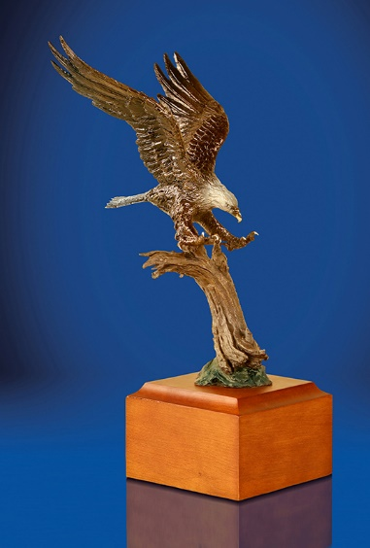

XX-15 MICHIGAN - PHEASANT HUNT FOR FOUR HUNTERS:
Tony Mazzali from Crooked Foot Hunt Club has generously donated a 20-bird pheasant hunt with shotguns for four hunters. Crooked foot Hunt Club is Mid-Michigan's newest hunting and sportsman club. Located northeast of Lansing (north of I69 and just east of M52), Crooked Foot specializes in upland bird hunting and hunting dog training on 300 acres of pristine countryside. This hunt must take place during October 2022 through April 2023 on open dates agreed upon with Jim Trotter, Crooked Foot Hunt Club manager. Donation includes 20 birds put out in the fields and hunting dogs with handlers during the walk-up hunt. Cleaning of the birds after the hunt is available for $1.25/bird. This hunt can be upgraded to include more hunters, more birds, and even overnight lodging per the Club's price list. Hunters are invited to bring their own dogs for use during the hunt. Contact Jim Trotter directly for more details and to book your hunt.
DONATED BY: CROOKED FOOT HUNT CLUB, Tony Mazzali (Owner)
Jim Trotter, Manager Phone: 515-599-4287
Kim Capone, Club Assistant Phone: 517-908-4714 or 989-723-9823
7303 South Delaney Road, Owosso, MI 48867
E-mail: crookedfoot@frontier.com Web: crookedfoothuntclub.com
Value: $725

XX-16 BRONZE BY LORENZO GHIGLIERI ENTITLED "HIGH TAIL":
Up for auction is an 18"Hx20"Wx9"D masterpiece bronze of a large antlered Whitetail buck entitled "High Tail" by renowned artist Lorenzo Ghiglieri. The sheer power, magnificence and magnitude of the works of this modern American Master transcend description through mere words. The visual impact of his artwork speaks volumes and moves the uninitiated fine art admirer, the novice fine art collector and the seasoned fine art aficionado, alike.
DONATED BY: FOUNDATION MICHELANGELO, Angie Zook
Phone: 503-747-5356
Email: angie@fineart1.com Web: fineart1.com
Value: $10,500
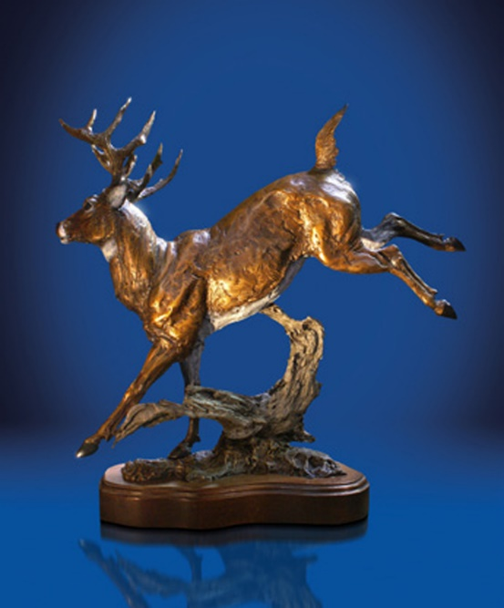

XX-17 FLORIDA – 1.5 DAY WILD BOAR HUNT WITH BAY DOGS FOR 4 HUNTERS:
This is a 1.5-day group hunt for four hunters using weapons of choice for wild boar with bay dogs at Ross Hammock Ranch, a Florida Premier Hunting Destination, that contains many species of both native and exotic game. The hunting ranch is located on Florida's Gulf Coast a two-hour drive NW from Orlando. Donation includes: all meals, snacks, drinks, guides, cook and maid service; one nights lodging in the fantastic RHR Cypress Log Lodge; use of 3D archery and gun ranges, ranch vehicles, and a pack of bay dogs that will insure a successful and very exciting hunt; basic skin/quarter/clean and ice down of game taken; and the trophy fee for the first hog taken by the group (one hog per group not per person). The purchasers of this hunt may add additional wild boars, other game, additional hunters and guests, additional hunting days and additional nights lodging at RHR published pricing (hog trophy fees are $295/meat hog and $595/trophy boar). Hunt to be taken within one year from the date of this auction. Contact Terra Ross directly for more details and to book your hunt.
DONATED BY: ROSS HAMMOCK RANCH, Terra Ross
P.O. Box 505, Inglis, FL 34449
Phone: 352-427-5807 or 352-303-7909
Email: rosshammockranch@gmail.com Web: rosshammockranch.com
Value: $2,159

XX-18 ARGENTINA - THREE DAY DOVE HUNT FOR 2 HUNTERS:
This is a three-day shotgun dove hunt for 2 hunters in the beautiful Cordoba area of Argentina, the dove hunting capital of the world, with Sporting Adventures International. There are 50 million doves in the Cordoba Valley and the birds never migrate. Here the dove season is open all year with no bag limits, so a hunter could shoot several thousand doves per day. Our rustic ‘estancias’ provide the perfect mix of comfort and charm, and we proudly boast of our experienced, hospitable staff. This extraordinary trip includes three full days of hunting for two people, all meals and accommodations with an open bar in one of our four well-appointed lodges. You and your travel partner will be met at the Cordoba airport where you’ll both enjoy a VIP reception complete with drinks and baggage handlers after your long trip. You’ll then be escorted in our private van to the lodge. This trip will include English speaking guides, all ground transportation to and from the hunting areas, bird boys, and gun cleaning. From the moment you step off the plane in Argentina until you reboard for the USA, our full-service courtesy will be at your disposal. With its amazing hunting, beautiful landscapes and iconic culture, Argentina is a must for every adventurous traveler. The purchasers of this package will be responsible for a $625 per person fee for the Cordoba airport meet and greet, transportation to the lodge and return, and landowner fee. The $625 fee is to be paid at the time of booking the trip. Not included are: airfare, shells
(available at lodge for $13.50/box), gun rental (available at lodge for $75/day) and gratuities. This three-day guided hunt can be scheduled for open dates in 2022 or 2023. Arrival and departure point is Cordoba Airport (COR). Contact Jacob Wallace for more details and to book your hunt.
DONATED BY: SPORTING ADVENTURES INTERNATIONAL, Jacob Wallace
1108 Atlas Road, Columbia, SC 29209
Phone: 803-638-4894 or 864-809-3166
Email: info@sportingadv.com or jacob@sportingadventures.com
Web: sportingadv.com
Value: $5,500

XX-19 ALASKA - FLY IN GUIDED SALMON FISHING TRIP FOR ONE ANGLER:
This is a 6-day/5-night fully-guided salmon fishing trip to the historic McDougall Lodge on Lake Creek approximately 60 miles NW of Anchorage for one person. This package includes full-time guide; floatplane from Anchorage to lodge and return; all fishing tackle, rods, and reels; lodging and meals; filleting, freezing and vacuum packaging your fish; morning arrival on your first day and early evening departure on the sixth day. This trip may be taken in 2022 or 2023 during fishing season June-September. NOT INCLUDED are: fishing license ($70 plus $30 for King Salmon stamp), airfare to Anchorage, gratuities, and alcoholic beverages. Winning bidder must bring a paying customer at full rate of $4,690. Additional anglers welcome at $4,690 each. Non-anglers and children under 12 are welcome at $2,345 each. Discounts may be negotiated for large groups. Contact Ron Jewett directly for more details and to book your trip.
McDougall Lodge, Ron Jewett
Phone: 928-529-5250 (office)
Email: info@mcdougalllodge.com Web: mcdougalllodge.com
Value: $4,690

XX-20 JEWELRY – CUSTOM CREATED BLUE SAPPHIRE AND DIAMOND RING:
Up for auction is a stunning piece of fine jewelry custom-created by Jewel Craft consisting of a Blue Sapphire and diamonds ring set in 14kt white gold. The wonderful cushion-cut center stone is a hefty 3.5 carats in weight beautifully surrounded by stunning bright white diamonds in this modern and sought-after halo design. The diamonds continue to shimmer down each side of the ring. Raise your hand to bid on a perfect piece of hunting insurance which is available in any size.
DONATED BY JEWEL CRAFT INTERNATIONAL, Joseph Karcher
22642 Foxmoor, Novi, MI 48374
Phone: 248-227-4454 Email: josephkarcher1@gmail.com
Value: $4,700

XX-21 $500 GIFT CERTIFICATE FOR TAXIDERMY WORK:
Darren and Jennifer Wehner of St. Clair Flats Taxidermy have generously donated a $500 gift certificate to be applied to new incoming work. This gift certificate expires at the end of 2023.
DONATED BY: ST. CLAIR FLATS TAXIDERMY, Darren and Jennifer Wehner
4566 Pointe Tremble Road, Algonac, MI 48001
Phone: 810-794-1810
E-mail: stclairflatstaxidermy@gmail.com Web: stclairflatstaxidermy.com
Value: $500

XX-22 $500 GIFT CERTIFICATE FOR TAXIDERMY WORK:
Darren and Jennifer Wehner of St. Clair Flats Taxidermy have generously donated a $500 gift certificate to be applied to new incoming work. This gift certificate expires at the end of 2023.
DONATED BY: ST. CLAIR FLATS TAXIDERMY, Darren and Jennifer Wehner
4566 Pointe Tremble Road, Algonac, MI 48001
Phone: 810-794-1810
E-mail: stclairflatstaxidermy@gmail.com Web: stclairflatstaxidermy.com
Value: $500

XX-23 JEWELRY – CUSTOM AMETHYST AND DIAMONDS RING:
Up for auction is another stylish example of fine jewelry from Jewel Craft. This is a stunning Amethyst and Diamonds ring set in solid 14 kt white gold. This beautiful deep-color Amethyst totals just under 2 carats in total weight. This center stone is a unique trillion-shape-cut and is wonderfully accented with 2 rows of sparkling white diamonds. If a beautiful Amethyst ring with a unique hard-to-find trillion-cut has been on your wish list, go ahead and bid on this one-of-a-kind piece of jewelry. The ring is available in any size.
DONATED BY JEWEL CRAFT INTERNATIONAL, Joseph Karcher
22642 Foxmoor, Novi, MI 48374
Phone: 248-227-4454 Email: josephkarcher1@gmail.com
Value: $4,000
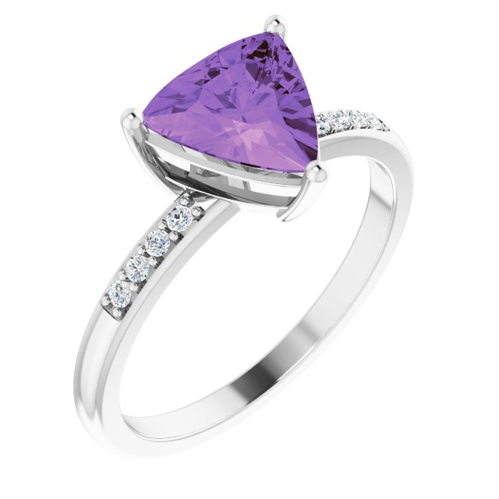
XX-24 MARYLAND - TWO DAY WATERFOWL HUNT FOR FOUR HUNTERS:
This is a donation for a 2-day shotgun hunt for four hunters in a blind with Chesapeake Goose & Duck Hunting in Maryland. Come join Professional Guide Kirby Bryan for some great waterfowl hunting on Maryland’s Eastern Shore! Species to be hunted include Canada geese and Green Wing, Blue Wing, Widgeon, Bufflehead, Gadwall, Scaup, Mallard, Pintail, Shovelers, Redhead, Woody and Canvasback ducks. There is a daily limit of six ducks and one Canada goose per hunter. Hunt can be taken mid-December, 2022 thru end of January, 2023 or mid-December, 2023 thru end of January, 2024. NOT INCLUDED: food and lodging and license and permit fees. Contact Kirby Bryan directly for more details and to book your hunt.
DONATED BY: CHESAPEAKE GOOSE & DUCK HUNTING, Kirby Bryan
9539 Chapel Rd., Easton, MD 21601
Phone: 410-310-6758
Email: kirby@chesapeakehunting.com Web: chesapeakehunting.com
Value: $1,600

XX-25 JEWELRY – CRUSHED OPAL SET:
Up for auction is another stunning Crushed Opal Set of jewelry that includes a brand-new modern choker style necklace, a bangle bracelet, a set of earrings and a ring (available in any size). This unique collection is sure to be a great addition to your jewelry collection as these pieces can be worn every day or just as easily for any formal occasion. Put up your hand to win this jewelry and try to count the number of compliments about to come your way.
DONATED BY JEWEL CRAFT INTERNATIONAL, Joseph Karcher
22642 Foxmoor, Novi, MI 48374
Phone: 248-227-4454 Email: josephkarcher1@gmail.com
Value: $3,000
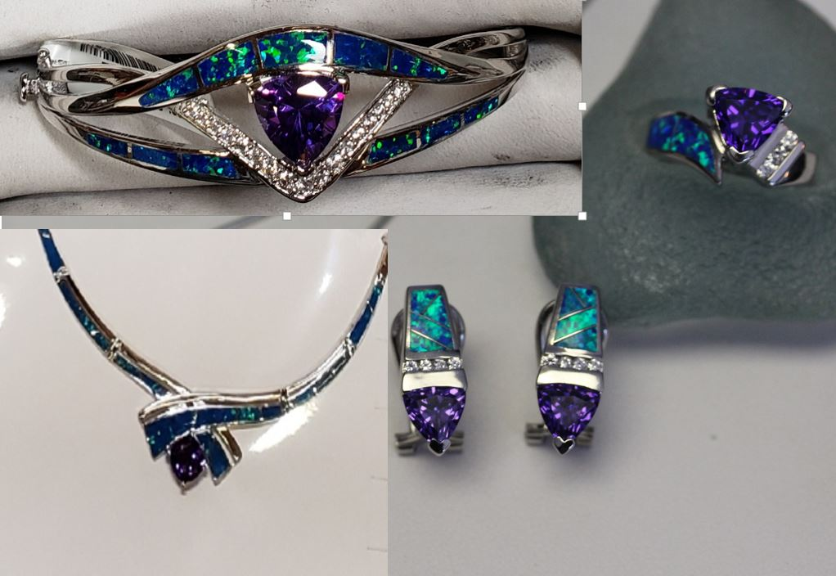

XX-26 TRIJICON ACCUPOINT 1-6x24 DUPLEX CROSSHAIR RETICLE RIFLE SCOPE:
This is a donation of a Trijicon 1-6x24 Trijicon AccuPoint riflescope with Duplex Crosshair with green dot reticle. The scope is illuminated through the use of fiber optics and tritium, providing a vivid aiming point that speeds target acquisition and extends available shooting hours without the need for batteries. Control the brightness of your fiber optic aiming point with the innovative illumination dial and have confidence with your shot placement in low light when the tritium kicks in. Designed to stand up to the elements, the Accupoint maintains the refinement needed for precise windage and elevation adjustments with no tools. The multi-layer coated lenses provide superior light transmission. The Accupoint also provides an easy focus eyepiece and long eye relief. This scope comes with a Trijicon logo sticker, a lens pen, a set of lens caps, an Accupoint Scope manual and a warranty card.
DONATED BY: TRIJICON
49385 Shafer Ave., P.O. Box 930059, Wixom, MI 48393
Phone: 800-338-0563 or 248-960-7700
Fax: 248-960-0563 Web: trijicon.com
Value: $1,399

XX-27 ARIZONA - 5 DAY COUES DEER HUNT FOR 2 HUNTERS:
This is a 5-day 2X1 guided Coues Deer hunt for two hunters in southern Arizona during the November 4-9 or November 25 – November 30, 2022 seasons. Hunt with rifle, handgun or muzzleloader. Hunters that choose to hunt with us are in for a real treat, as we have some awesome ranches that consistently produce trophy animals. Hunters can expect to see several bucks a day. Primary means of hunting will be long hours of glassing with high quality optics followed by spot and stalk. Other hunting methods will be using tree stands, sitting by water holes and natural mineral licks, and still hunting. Donation includes lodging, meals, trophy recovery and field prep, guiding, and transportation during the hunt. Not included are license fees ($360). Draw application deadline is second Tuesday in June with 99% draw rate. If you do not draw the first year, outfitter will help you apply for your hunt for the next year. Hunt arrival point is Tucson, Arizona. Non-hunters welcome at $250 each. Contact Steven Ward directly for more details and to book your hunt.
DONATED BY: WARDS OUTFITTERS LLC., Steven Ward
P.O. Box 337, Wilcox, AZ 85644
Phone: 520-404-5114 Cell: 520-404-5114
Email: trophyhunts@wardsoutfitters.com Web: wardsoutffiters.com
Value: $11,000

XX-28 ARIZONA - 5 DAY MULE DEER HUNT FOR 2 HUNTERS:
This is a 5-day 2X1 guided Mule Deer hunt for two hunters in southern Arizona during the October 28 – November 2 or November 18 - 23, 2022 gun seasons or December 16, 2022 thru January 31, 2023 archery seasons. Hunt with rifle, handgun, muzzleloader or archery. Hunters that choose to hunt with us are in for a real treat, as we have some awesome ranches that consistently produce trophy animals. Hunters can expect to see several bucks a day. Primary means of hunting will be long hours of glassing with high quality optics followed by spot and stalk. Other hunting methods will be using tree stands, sitting by water holes and natural mineral licks, and still hunting. Donation includes lodging, meals, trophy recovery and field prep, guiding, and transportation during the hunt. Not included are license fees ($360). Draw application deadline is second Tuesday in June with 80% draw rate. If you do not draw the first year, outfitter will help you apply for your hunt the following year. Hunt arrival point is Tucson, Arizona. Non-hunters welcome at $250 each. Contact Steven Ward directly for more details and to book your hunt.
DONATED BY: WARDS OUTFITTERS LLC., Steven Ward
635 W. Delos Street, Wilcox, AZ 85643
Phone: 520-384-3351 Cell: 520-404-5114
Email: trophyhunts@wardsoutfitters.com Web: www.wardsoutffiters.com
Value: $13,000

XX-29 ALASKA - FLY IN GUIDED SALMON FISHING TRIP FOR ONE ANGLER:
This is a 6-day/5-night fully-guided salmon fishing trip to the historic McDougall Lodge on Lake Creek approximately 60 miles NW of Anchorage for one person. This package includes full-time guide; floatplane from Anchorage to lodge and return; all fishing tackle, rods, and reels; lodging and meals; filleting, freezing and vacuum packaging your fish; morning arrival on your first day and early evening departure on the sixth day. This trip may be taken in 2022 or 2023 during fishing season June-September. NOT INCLUDED are: fishing license ($70 plus $30 for King Salmon stamp), airfare to Anchorage, gratuities, and alcoholic beverages. Winning bidder must bring a paying customer at full rate of $4,690. Additional anglers welcome at $4,690 each. Non-anglers and children under 12 are welcome at $2,345 each. Discounts may be negotiated for large groups. Contact Ron Jewett directly for more details and to book your trip.
McDougall Lodge, Ron Jewett
Phone: 928-529-5250 (office)
Email: info@mcdougalllodge.com Web: mcdougalllodge.com
Value: $4,690

